Maria Jose Viveros Riquelme

Professor Anna Devarakonda

ITAI 2372

April 8, 2026
Detailed Solution Plan: RA-HandRisk – A Conceptual AI System for Early Rheumatoid Arthritis Risk Screening

The RA-HandRisk system is designed as a conceptual artificial intelligence framework that integrates multiple sources of information to estimate the early risk of rheumatoid arthritis through a structured and interpretable flow of data. Instead of relying on a single indicator, the system combines clinical knowledge, self-reported information, and visual analysis of the hands, reflecting the multifactorial nature of the disease (National Institute of Arthritis and Musculoskeletal and Skin Diseases, 2023; Smolen et al., 2016). In this sense, the system can be understood as a pipeline where information moves through sequential stages, from data collection to risk estimation, allowing a more comprehensive evaluation.

At the beginning of this process, the system collects input data from two main sources: a structured survey and hand images. The survey plays a critical role because many of the most relevant risk factors for rheumatoid arthritis are not visually observable. For instance, variables such as age, sex, smoking history, and family history represent baseline susceptibility and environmental exposure, which are strongly associated with disease development (Centers for Disease Control and Prevention, 2023). In addition, the survey captures early clinical symptoms, including morning stiffness, joint pain, fatigue, and functional limitations, which are commonly reported in early stages of rheumatoid arthritis (National Health Service, 2023). These inputs are collected through guided questions, where qualitative responses are later transformed into structured variables. For example, morning stiffness is categorized by duration, and smoking is classified by status and exposure, which allows the system to quantify subjective experiences.

In parallel, the system collects hand images under standardized conditions, including an open hand and a closed fist. These two positions are selected because they allow the capture of both structural and functional characteristics of the joints. The open hand provides information about joint contour, swelling, and symmetry, while the closed fist allows the evaluation of movement limitations and stiffness. Since rheumatoid arthritis often affects the small joints of the hands and tends to present symmetrically, this visual information becomes relevant for screening, even though it cannot independently confirm the disease (National Institute of Arthritis and Musculoskeletal and Skin Diseases, 2023).

Figure 1 represents the flow of information from inputs (survey and images) through processing, risk integration, and final output.
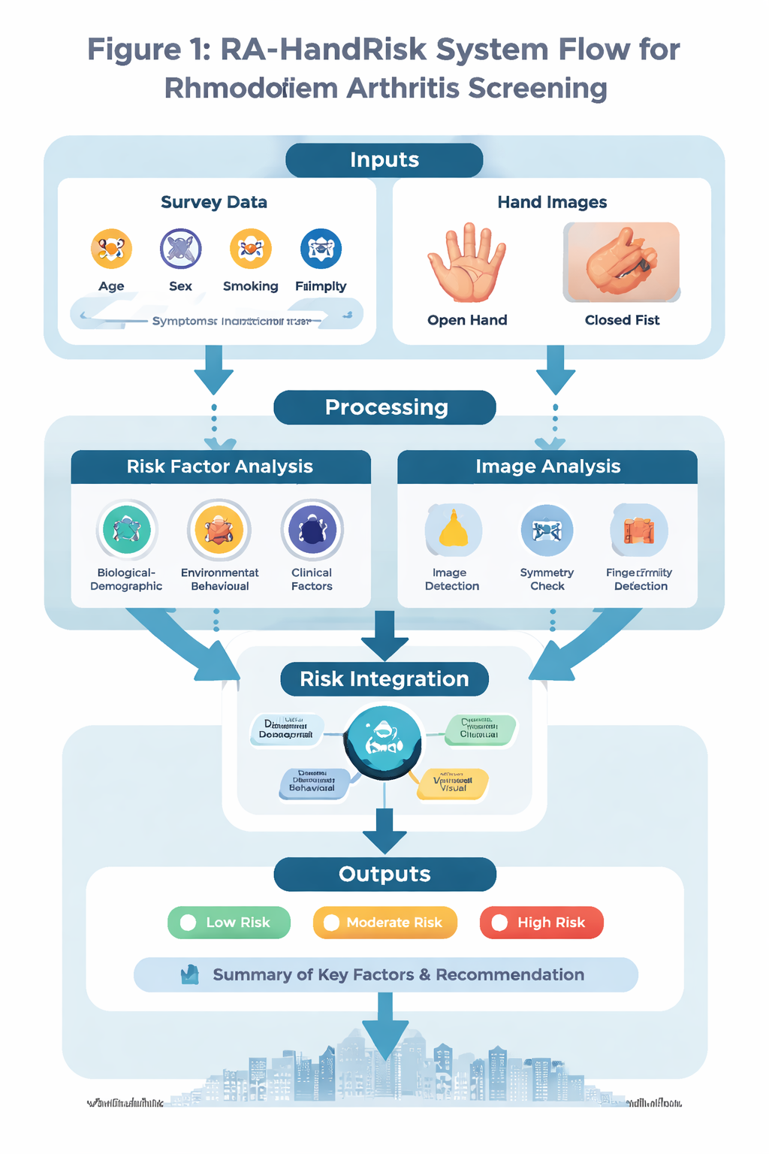

Once the data are collected, the system enters the processing stage, where both data streams are analyzed separately. On one hand, the survey responses are transformed into structured variables through a process of encoding and categorization. For example, age is grouped into clinically relevant ranges, smoking is encoded as categorical or ordinal data, and symptom duration is represented as scaled values. This step is essential because it standardizes heterogeneous inputs and prepares them for integration into a unified model.

On the other hand, the image analysis component applies computer vision principles to extract meaningful features from hand photographs. Conceptually, this involves identifying visual patterns associated with inflammation and joint changes. For instance, joint swelling can be detected by analyzing contour expansion around specific regions such as the metacarpophalangeal and proximal interphalangeal joints. Similarly, symmetry can be evaluated by comparing the geometry of both hands, while finger alignment can be assessed by measuring deviation angles. In addition, the closed fist image allows the system to estimate functional limitations by evaluating the degree of finger flexion. Although these features are not sufficient for diagnosis, they provide additional signals that complement the clinical and demographic data (Smolen et al., 2016).

After processing, the system integrates all variables into a unified risk model. This integration is organized through a conceptual structure that groups variables into four domains: biological-demographic factors, environmental-behavioral factors, clinical symptoms, and visual hand features. This organization improves interpretability because it allows the system to explain how different types of information contribute to the final result. For example, a user may have minimal visual abnormalities but significant clinical symptoms and smoking history, which together increase the overall risk. Conversely, visual changes without supporting clinical indicators may result in a lower risk classification.

The integration stage is conceptually modeled using a probabilistic approach, such as logistic regression, where each variable contributes to the final risk score based on its statistical relevance. Importantly, the weights assigned to each variable are not predefined but would be learned from clinical datasets, ensuring that the model reflects real-world patterns rather than subjective assumptions (Sparks, 2019). The output of this process is a probability value between zero and one, representing the likelihood of elevated rheumatoid arthritis risk.

Finally, the system translates this probability into an interpretable output for the user. Instead of presenting a raw numerical value, the system categorizes the result into three levels: low, moderate, or high risk. In addition, it provides a summary of the main contributing factors, such as prolonged stiffness, bilateral pain, or smoking history, and includes a recommendation for further medical evaluation when appropriate. This design enhances usability and aligns with clinical decision support principles, where clarity and actionability are essential.

To further support understanding, the system design includes the use of visual representations. The main infographic (Figure 1) illustrates the overall flow of information, while additional graphics can be incorporated to show the contribution of each factor to the final risk score. For example, a bar chart can represent the relative weight of each variable, and a cluster diagram can illustrate the relationship between different domains of risk. These visual tools not only improve communication but also increase transparency, which is particularly important in healthcare applications.

Despite its strengths, the system has important limitations. Hand images alone cannot confirm rheumatoid arthritis, and early stages of the disease may not produce visible changes. In addition, the model depends on the availability of high-quality and diverse datasets for training and validation. There is also a risk of misclassification, which reinforces the need to use the system as a screening tool rather than a diagnostic instrument. Therefore, the system must clearly communicate its purpose and limitations to avoid misuse.

In conclusion, the RA-HandRisk system represents a structured and theoretically grounded approach to early rheumatoid arthritis risk screening. By integrating survey-based data and image-derived features within a unified flow of information, the system reflects the complexity of the disease and demonstrates how artificial intelligence can support early detection in a realistic and interpretable way.

